REVISION TRACKING TABLE
Rev. _ No. | Revision Rationale | History
01 | Corrected in accordance with ISO/IEC 17021-1 requirements . | 29.03.2017
02 | ADAPTED ACCORDING TO TURKAK GUIDE 10.06 | 02.05.2018
03 | General Review | 01.02.2022
04 | Arrangements have been made in accordance with ISO 22003-1:2022 Article no 8, and the relevant places are written in italics. | 07.03.2023

DOCUMENT CONFIRMATION TABLE
Preparer | controlling | approver
management representative | Certification Manager | General manager

- PURPOSE and SCOPE
The purpose of this instruction is to determine the rules for the use of certification logos and documents .

This instruction covers the usage rules of DSR system certification logos and documents as well as accreditation body logos.

- DEFINITIONS
-

- APPLICATION
  - General
This instruction contains common terms for the use of certification logos and documents. Common terms should be applied indiscriminately to the use of certification logos and documents. Non-common terms are specified in separate articles and include special conditions that must be applied for the use of certification logos and documents.

  - Logo and Document Usage Rules (General)
Persons or organizations that are entitled to receive a certificate must use the logos and documents for which they have the right to use, in accordance with the terms and rules written in this instruction.

The logo and document usage rules are as follows:

a. DSR logos can be used by individuals or organizations that have been successful in the audits conducted by DSR and whose certificate validity continues. In case of unauthorized use of DSR logos by third parties, legal sanctions are initiated.

b. DSR logos can be sent on CD or e-mail upon request , and the logos can be accessed from the DSR website.

c. Persons or organizations that are entitled to receive a certificate from DSR must comply with the conditions and rules specified in the "Requirements for the Use of R10.06 TÜRKAK Accreditation Mark by TÜRKAK Accredited Organizations" published by the Turkish Accreditation Agency (TÜRKAK) in addition to the conditions of this instruction. has to. This document is given to the person or organization upon delivery of the documents. In addition, current versions of this document can be accessed from the official website of TÜRKAK . ( www.turkak.org.tr )

D. DSR logos cannot be used in a way that would imply that DSR is responsible for the content of the documents used or the related activities .

to. DSR logos and documents cannot be used in departments, affiliated persons or organizations or affiliates that are not covered by the document.

f. The DSR logo can only be used in the fields of activity within the scope of the document.

g. In case of cancellation of the contract, expiry of the certificate, suspension or cancellation of the certificate, the person or organization must immediately stop the use of the logo and documents. The person or organization is obliged to send the original documents that have lost their validity to DSR.
h. DSR system documents are issued to legal entities and all usage rights belong to the legal entity on whose behalf the document is issued. The right to use documents and logos cannot be transferred to third parties.

I. Certified persons or organizations are obliged to comply with the terms and rules of this instruction as long as the validity of the certificate continues.

j. In case of misleading and/or inappropriate use of DSR logo and document, all legal rights belong to DSR. DSR reserves the right to bring legal proceedings at any time.

k. If a logo use other than this instruction is detected, suspension and cancellation of the document will be implemented and action will be initiated in accordance with the legal regulations.

l. DSR controls the use of logos and documents by individuals or organizations in planned audits and complaints and objections. Persons or organizations must show the areas of use of logos and documents to the auditors or controllers.

m. DSR logos,
- It cannot be used by multiple copies on the same document .
- It is not used disproportionately.
- It should be of such a size that all its features can be seen in detail.
- that its length is at least 15 mm .
- It should be used in original colors or black and white .
- It cannot occupy more than half of the document it is used in.
- If it is necessary to use a different logo other than this instruction, approval must be obtained from the Certification Manager .

he. DSR reserves the right to change the conditions specified in this instruction without prior notice. Persons or organizations are obliged to constantly follow and implement the current version of this instruction on the DSR website.

p. Every person or organization that enters into a commercial relationship with DSR is deemed to have accepted the legal terms specified and unspecified in this instruction.

r. The certified body is obliged to ensure that all advertising materials are changed accordingly when the scope of certification is narrowed.

s. The certified body should ensure that the certification of its management system does not allow DSR to be used in such a way as to give the impression that it certifies a product (including service) or process.

t . The certified body should ensure that it does not use the certificate it has received in a way that will discredit the DSR or the certification system and lose public trust .

u. TÜRKAK DOCUMENT VERIFICATION SYSTEM (TBDS) SQUARE CODE: Provides access to information about the document produced by the TÜRKAK document verification system, where some records and information (application, scope, audit, etc.) regarding the management system certifications given or to be given to customers receiving service from DSR are entered . QR code.
The TÜRKAK code to be used under the QR code is given by the system after the information is entered on the TBDS platform and consists of 9-10 alphanumeric characters. DSR; In the documents it has issued, the document query of the company receiving the document is provided by reading the QR code with mobile devices or by querying it with the TBDS Document number at https://tbds.turkak.org.tr.

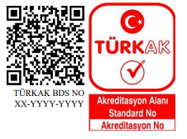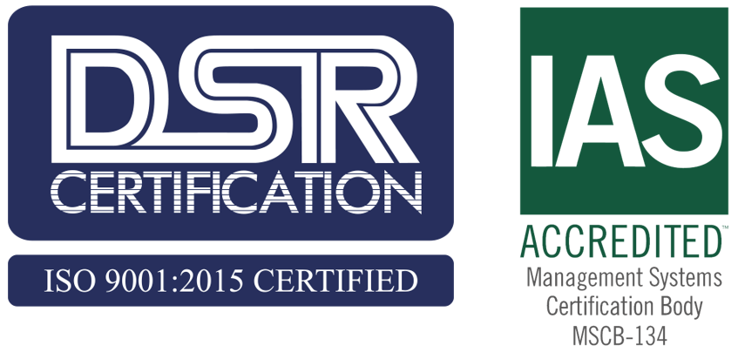

  - Logo and Document Uses
certification logos and documents are as follows :
DSR certification logos;
- a product certificate.
- of the products .
- with a statement and explanation indicating that the document belongs to the management system, not the product, in the outer packaging used for the transportation of the products and not thought to reach the end user . (For example, it can be a clear statement as “This product has been produced in company A [company name must be specified] which is certified by DSR according to ISO 9001:2015 Quality Management System standard . " )
- in publications or brochures for advertising purposes . (For example ; letterhead, invoices, business cards and other materials that require paper use )
- Upon withdrawal or suspension of certification by DSR, the client is warned to cease all advertising activities involving a reference to certification.
- The IAF Mark cannot be used by the customer in any way.
- DSR does not allow the use of the GGYS certification mark on the product packaging. DSR has guaranteed it with this Documentation Rules agreement. In the context of this document, product packaging referred to in ISO/IEC 17021-1:2015, 8.3, covers all product packaging, both primary packaging (containing the product) and any outer or secondary packaging (ISO 22003-1:2022)

  - Use of the Accreditation Logo and Some Restrictions
The accreditation logo must be used in accordance with the terms and rules in the Accreditation document specified in the “ 3.2 ” article . The rules and some restrictions on the use of the accreditation logo are given below :

a. accreditation logo can be used in stationery, advertisement, promotion and similar materials, if the document is within the scope of accreditation, it cannot be used on business cards.

b. The term “Promotional Materials” includes notes, labels, documents or written notices attached to products and materials other than products or goods manufactured under an accredited product certification activity. This restriction also applies to packaging and promotional materials.

c. The accreditation logo cannot be used alone without the DSR logo .
D. Accreditation and DSR logo cannot be used in separate places and in different sizes and in a way that dominates each other.
to. The accreditation logo cannot be used more than once on the same material.
f. If the accreditation logo is printed on a consumable larger than A4, its width should not be larger than 30 mm.
g. The accreditation logo can be used in the form of embossing and hologram.
h. accreditation The logo cannot be used on vehicles.
I. The accreditation logo cannot be used on buildings and flags.
j It should not be corrupted for any purpose, its format should not be changed or tampered with, it should be used as it is in the electronic version .
k. The Accreditation logo should not be used to imply that a product has been approved by Accreditation.
l. The use of the logo in laboratory tests, calibration and inspection reports and similar reports is prohibited.

  - Simple Rule
If you are unsure or in doubt whether to use it , consult us first so we can avoid many potential problems in the future.

  - logos
The DSR Logo can be used as follows.
